Providing Dynamically Changeable Physical Buttons on a Visual Display

【Summary】：In this paper, we describe a technique for creating dynamic physical buttons using pneumatic actuation. This technique allows aspects of physical form and appearance to be dy-namically modified under program control - buttons can be brought into and taken out of an interface as needed, and it allows a small set of distinct interface elements to occupy the same physical space at different times.

【Five design goals】：

1) Inexpensively manufactured (i.e., simple construction, cheap materials).

2) Easily actuated.

3) Able to display graphics without occlusion from hands or pneumatic/control elements.

4) Able to sense user input (and not occlude the display).

5) Provide support for tactile expression beyond simple on/off state changes.

【Design】：

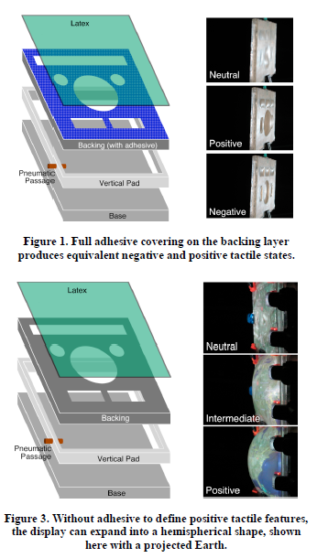 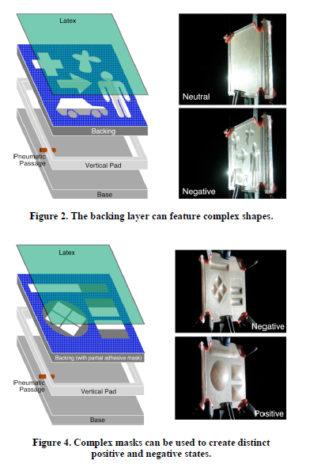

【user study】:

**Four surface:**

**1) Flat – a sheet of acrylic; designed to mimic a touch screen interface.**

**2) Physical Buttons – a sheet of acrylic with physical, protrusions; designed to mimic buttons.**

**3) Negative Pneumatic Buttons – pneumatic tactile display with concave features.**

**4) Positive Pneumatic Buttons – pneumatic tactile display with convex features.**

**Procedure:**

Participants were seated in front of a laptop computer run-ning a custom, full-screen application (Figure 17). A full-sized mouse was provided for input. The right side of the screen featured a layout matching the test surfaces. After a random period of time between 2 and 14 seconds, a button would activate by “lighting up” (see top-right-most button in Figure 17). This indicated to the participant that they should press the corresponding button on the test surface. Each button was activated, in a random order, four times for each of the four test surfaces (which were also presented in a random order).

**Results:**

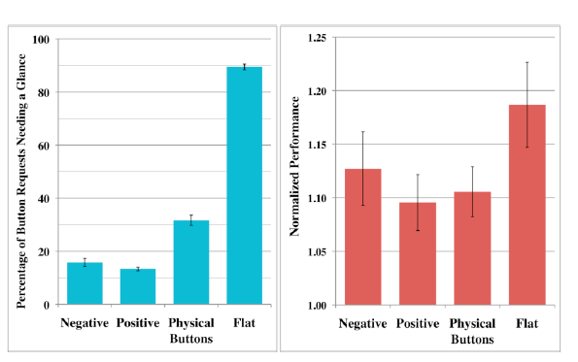 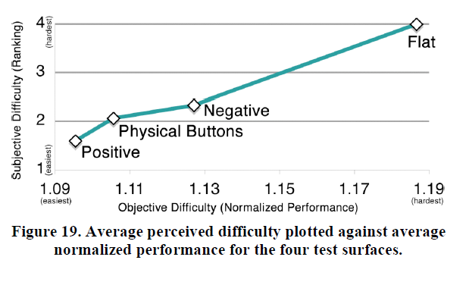

【Conclus】：

We have presented a range of methods for producing pneumatically actuated, dynamic, physical but-tons on a visual display. The use of clear acrylic allows the displays to be rear projected, avoiding occlusion from user input. Multitouch sensing can be achieved with an infrared-based computer vision system. Additionally, we outline several interesting ways barometric features could be used to enhance input functionality. To help motivate the tech-nology, we detailed three example applications where pneumatic tactile displays could be usefully deployed. We concluded with the results from our preliminary user study, which suggests our dynamic button displays have tactile qualities similar to that of physical buttons.

